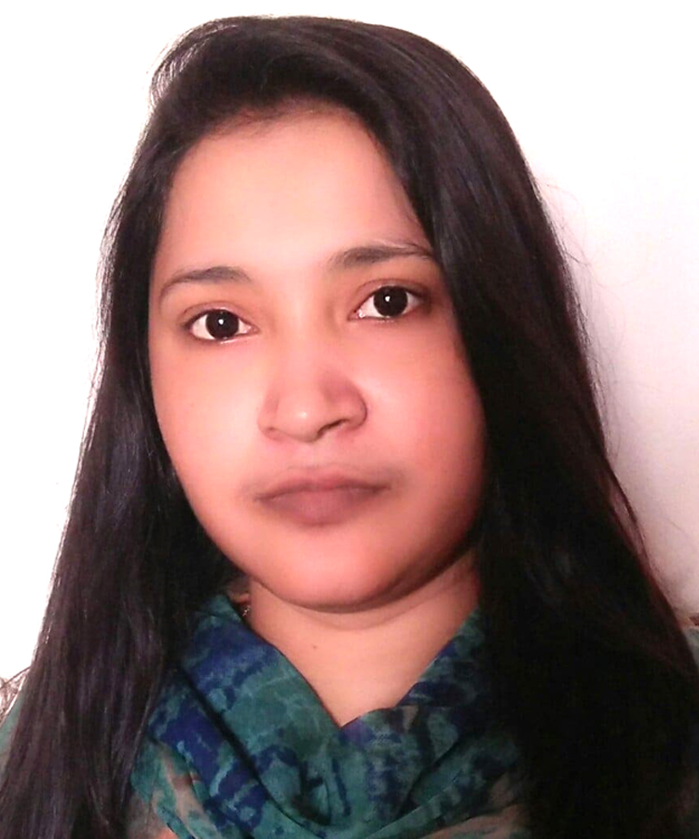
Mary Brooks
ADDRESS - House: K/45, Panthokutir, Kuril Chawrasta, Dhaka 1212
CELL +880 01776 214462 • E-MAIL mary.brooks1505@gmail.com

CAREER OBJECTIVE To build a challenging career through my complete dedication to the effort as well as to prove myself as a competent person for the position of an employee in corporate fields and work in an environment where there in an opportunity of self-assessment and improvement in both individual and group-based jobs that frequently faces various critical challenges and service the community with individual skills.

WORK EXPERIENCE Basha Enterprise Ltd
Branch Manager (Dhaka Branch)
1st November 2022 to till now
Responsibilities: Staff Management, Accounts (Salary, Voucher, Pay Roll etc)

Basha Enterprise Ltd
Branch Manager (Mymensingh Branch)
1st July 2016 to 31st October 2022
Responsibilities: Staff Management, Accounts (Salary, Voucher, Pay Roll etc)

Friends of Basha
Day Care Supervisor (Mymensingh Branch)
13th May 2012 to 30th June 2016
Responsibilities: Child Care, Staff Management etc.

EDUCATION Masters (In progress)
Social Science
Bangladesh Open University
In progress

Degree (2018)
BA/BSS
Bangladesh Open University
GPA 2.56 out of 4.00

Higher Secondary Certificate (2009)
Business Studies
Rupsha Degree College
GPA 3.70 out of 5.00

Secondary School Certificate (2008)
Business Studies
Kazdia High School
GPA 3.63 out of 5.00
LANGUAGE Bangla (Mother Tongue)
English (Satisfactory in Speaking and have good command in writing)

SOFTWARE SKILLS Microsoft Office (ms-word, ms-excel, ms-powerpoint)
Browsing (at Windows Platform)
Email (Gmail, Yahoo, Outlook etc)

CAPABILITIES Self-motivated, Have patient, Goal oriented, Interpersonal skill, Work sincerity, hard worker.

INTERESTS Media (Listening Instrumental, Enjoying Movies)
Self (Singing, Dancing, Photography, Reading)
Others (Researching, Poetry, Travelling)

BIOGRAPHY Full Name Mary Brooks
Father’s Name Warren Brooks
Mother’s Name Jane brooks
Present Address House: K/45, Panthokutir, Kuril Chawrasta, Dhaka 1212
Permanent Address House: K/45, Panthokutir, Kuril Chawrasta, Dhaka 1212
Date of Birth 15th May 1991
Religion Christian
Marital Status Unmarried
Blood Group B+
Height 5 feet 1 inches
Nationality Bangladeshi (By Born)

I undersigned, do hereby declare that to the best of my knowledge and brief this resume correctly describes my qualifications, my experience and me.


August 07, 2022
DATE SIGNATURE

